National University of Computer & Emerging
Sciences
Karachi Campus

PROJECT REPORT


Course | Data Structures (CL-2001)
Project Title | Document Indexer & Plagiarism Detection Engine
Submitted by | Muhammad Anas – 25K-0899  Syed Alyan Hussain – 25K-0648
Submitted to | Muhammad Qasim Keeryo
Department | Department of Computer Science, FAST University
Semester / Section | 3rd Semester / BCS-3C
Date of Submission | November 2026
Implementation Language | C++17 (all core data structures implemented from scratch)

Before printing, check the date of submission and the roll numbers on this page. The FAST seal is the same image that is used on the course proposal, so this report and the proposal look like one document.

Table of Contents
Table of Contents will appear here: click here and press F9 (Update entire table) in Microsoft Word.
In Microsoft Word, click inside the table above and press F9, then choose 'Update entire table'. The page numbers below then match the printed report.
List of Figures
Figure 6.1 System architecture of the engine: seven stages, one structure per stage
Figure 6.2 Data flow of one run: from the folder of files to the ranked report
Figure 7.1 k-gram fingerprints produced by the rolling hash (k = 5)
Figure 7.2 Hash table with separate chaining: word to posting list, eight buckets
Figure 7.3 KMP prefix (LPS) table for the pattern “ababaca”
Figure 7.4 Max heap used for the top-K list of suspicious pairs
Figure 7.5 AVL tree: the four imbalance cases and their rotations
Figure 7.6 Similarity graph and the clusters found by breadth-first search
Figure 11.1 Index statistics of the demo corpus (screenshot)
Figure 11.2 Hash-table lookup of the word “total” (screenshot)
Figure 11.3 Phrase search with brute force, KMP and Rabin-Karp (screenshot)
Figure 11.4 Detected suspicious pairs with copied line ranges (screenshot)
Figure 11.5 Top-3 suspicious pairs taken from the max heap (screenshot)
Figure 11.6 Full leaderboard produced by the AVL tree (screenshot)
Figure 11.7 Plagiarism clusters found by BFS on the similarity graph (screenshot)
Figure 11.8 Vocabulary from the BST in-order traversal and binary search (screenshot)
Figure 12.1 Result of the six test programs under CTest (screenshot)
Figure 13.1 Score of each pair as the window size k grows
Figure 13.2 Measured time of the three phrase-search algorithms

1. Executive Summary
This report describes a command-line plagiarism detection engine written in C++17 for the Data Structures course (CL-2001). The program takes a folder of text files and C/C++ source files, indexes every word in it, compares every pair of documents, and prints a ranked list of the pairs that look copied, together with the exact line ranges that the two documents share. It works offline, without a database and without any third-party library, and every data structure inside it was implemented from scratch.
The work was carried out in the same seven stages that were promised in the project proposal, and each stage is handled by one structure from the course outline:
- File ingestion – a linked list of documents, and a stack used to undo the cleaning of a line.
- Tokenization – the text is lower-cased, comments are removed and the text is cut into words, each word remembering its document and line number.
- Indexing – a hash table with separate chaining maps every distinct word to the list of places where it appears; the same data is also inserted into a linear-probing table, so the two collision policies can be compared.
- Fingerprinting – a polynomial rolling hash turns every k consecutive words (k = 5) into one 64-bit number in constant time per slide.
- Candidate detection – the fingerprints of two documents are sorted and merged, and the Jaccard coefficient decides whether the pair deserves a closer look.
- Verification – the Knuth-Morris-Pratt algorithm searches the surviving pair for its longest copied run of words and returns the line ranges.
- Ranking and reporting – a merge sort, a max heap (top-K), an AVL tree (full leaderboard), a graph with breadth-first search (clusters of students) and a binary search tree (the vocabulary) produce the final report.
The engine was tested on a corpus of six student files. It reports the verbatim copy with a similarity score of 1.000, a copy in which the function names were changed with 0.444, and a half copy with 0.302, and it correctly stays silent about the two files that were written honestly. Indexing the corpus takes about 0.4 milliseconds and the whole comparison about 4.1 milliseconds, so a folder of a few hundred files is processed in well under a second. Six test programs with about 250 checks pass under CTest.
The engine is deliberately simple. It compares words, not meanings, so it does not detect a copy that was paraphrased sentence by sentence or a copy that was translated into another language. Section 13.5 states these limits plainly instead of hiding them, because a tool that a teacher can explain to a student is more useful than one that produces a number nobody can defend.

2. Problem Statement
Every semester a lab instructor receives dozens of submissions of the same assignment. A few of them are copies of each other, sometimes with the variable names changed or the functions renamed and reordered, and finding those copies by opening the files one by one is slow, tiring and unreliable. The problem this project solves is to do that comparison automatically and to justify the result.
Stated formally, the engine receives a folder of n documents D = {d1, d2, …, dn}, a window size k and a similarity threshold t, and must report every pair (di, dj) whose similarity is at least t, ordered from the most similar pair downwards, with the line ranges that the two documents have in common. The following requirements were fixed before the design started:
- Self-contained: no database, no network connection and no third-party library; only the C++ standard library for strings, files and timing. The containers themselves (vector, map, priority queue) are not used, because using them would remove the point of the project.
- Fast enough: a folder of a few hundred small files must be indexed and compared in under a second on an ordinary laptop.
- Repeatable: the same folder must produce exactly the same output on every run, so that a result can be shown to a student and defended.
- Explainable: every number printed by the program must come from a data structure that the team can describe, and whose complexity the team can derive.
- Evidence, not only a score: a teacher cannot act on the number 0.44 alone, so the program must print the lines that match.

3. Objectives
The objectives below are the ones written in the proposal, restated with the outcome that was actually achieved for each of them.
1. Build an inverted index from scratch. A hash table with separate chaining maps a word to the documents and lines where it appears, with rehashing at a load factor of 0.75. Achieved: module hash_table, load factor 0.398 on the demo corpus, longest chain 3.
2. Detect copied text in two stages. A cheap k-gram fingerprint filter (rolling hash + Jaccard) followed by an exact verification with KMP. Achieved: 15 pairs compared, 6 reported, no false positive on the two independent files.
3. Provide phrase search with three algorithms. Brute force, KMP and Rabin-Karp answer the same query, so each one can be the test of the other two. Achieved: the three always report the same number of matches.
4. Rank and group the results with the structures of the course. Merge sort for the score list, a max heap for the top-K pairs, an AVL tree for the full leaderboard, and a graph with BFS for the clusters of students. Achieved: all four are in the working program and in the screenshots of section 11.
5. Keep the code readable. One data structure per file, each file short enough to be explained line by line in a viva. Achieved: 15 modules, none longer than about 120 lines.
6. Produce evidence that can be checked. A test program for every structure, a demo corpus with a known answer, and one document that explains how to reproduce each screenshot. Achieved: 6 test programs, about 250 checks, all passing.

4. Scope
The project is a small, transparent plagiarism detector for a course lab. The two lists below fix what it does and what it deliberately does not do, because a report that promises more than the program does is worse than a report that promises less.

4.1 In Scope
- Plain text (.txt), Markdown (.md) and C/C++ source files (.c, .cpp, .h) up to 2 MB each.
- Cleaning and tokenization: removal of comments, lower-casing, splitting on anything that is not a letter or a digit, and remembering the document and the line of every token.
- An inverted index built on a hash table with separate chaining, plus a second index with linear probing for the collision comparison.
- k-gram fingerprints with a polynomial rolling hash, k configurable between 3 and 8.
- Jaccard similarity between the fingerprint sets of two documents, with a configurable threshold and a verdict band (CRITICAL, HIGH, MEDIUM, LOW).
- Verification of the reported pairs with KMP, which returns the copied line ranges.
- Ranking with merge sort and a max heap (top-K), a full leaderboard in an AVL tree, clusters with a graph and BFS, and a vocabulary in a binary search tree.
- Phrase search with brute force, KMP and Rabin-Karp, printing the time of each.
- A menu-driven console report that can also be written to a text file.

4.2 Out of Scope
- PDF, Word, PowerPoint and image files. Reading them would need a library and would not teach any data structure.
- Meaning-level comparison (paraphrasing, translation, synonym replacement). The engine compares word sequences, so a paraphrase scores low on purpose.
- Syntax trees, program dependence graphs and token weighting, which belong to the structure-based family of detectors and are far beyond the scope of one semester.
- A web interface, a database, multiple users and stored history. The program is a console application that runs on one folder at a time.
- Automatic grading. The program reports evidence; deciding what to do with it stays with the instructor.

5. Course Topic Mapping
Table 5.1 maps every topic of the Data Structures course outline that this project uses to the place where the engine uses it, and states the complexity of the operation. The third column is the complexity that the team must be able to derive in the viva.
Table 5.1: Data structures of the course mapped to their role in the engine
Data Structure | Functional Role in System | Algorithmic Complexity
Array (DynamicBuffer) | Contiguous storage of tokens, of the document list and of the pair list; grows by doubling, used everywhere a list of items is needed | Append O(1) amortized, access O(1)
Singly Linked List | Posting lists of the inverted index (one node per word occurrence) and the chain of a hash bucket | Insert at head O(1), traversal O(m)
Stack | Undo buffer while cleaning a line: the words of the line in progress are pushed and popped, which reverses them for the comment filter | Push O(1), pop O(1)
Queue | Breadth-first search over the similarity graph; documents waiting to be visited by the cluster search | Enqueue O(1), dequeue O(1)
Hash Table (separate chaining) | The inverted index: word → posting list, 256 buckets, rehash at load factor 0.75 | Average O(1) search, insert, delete; worst case O(n)
Hash Table (linear probing) | Second index built from the same tokens, used to compare open addressing with chaining on identical data | Average O(1); clustering raises the probe count
Rolling Hash (Rabin-Karp) | k-gram fingerprints: one 64-bit number per window, updated in O(1) when the window slides by one word | Fingerprint set O(n), compare O(g log g)
KMP String Matching | Verification: finds the longest copied run of words inside a reported pair and returns its line range | Prefix table O(m), search O(n + m)
Binary Search Tree | The vocabulary: distinct words in alphabetical order by in-order traversal; binary search on the sorted array for a word | Average O(log n), worst case O(n) when unbalanced
AVL Tree | Full leaderboard of pairs, kept balanced by rotations so the height stays logarithmic | Search, insert, delete O(log n) guaranteed
Max Heap | Top-K suspicious pairs: the heap keeps the K largest scores without sorting the whole list | Build O(n), extract-max O(log n), top-K O(n log K)
Graph (adjacency list) + BFS | Similarity graph: an edge between two documents above the threshold; connected components give the groups that copied together | Build O(V + E), BFS O(V + E)
Merge Sort | Orders the pairs by score and the fingerprints of a document before the merge | O(n log n) time, O(n) memory
Binary Search | Looks a word up in the sorted vocabulary and a fingerprint up in the sorted fingerprint array | O(log n)

6. System Architecture & Pipeline

6.1 Architecture
The engine is a pipeline of seven stages. Each stage reads the output of the previous stage and owns exactly one data structure, which is why the two members of the team could build their halves separately and join them at the end. Figure 6.1 shows the stages and the structure responsible for each of them.
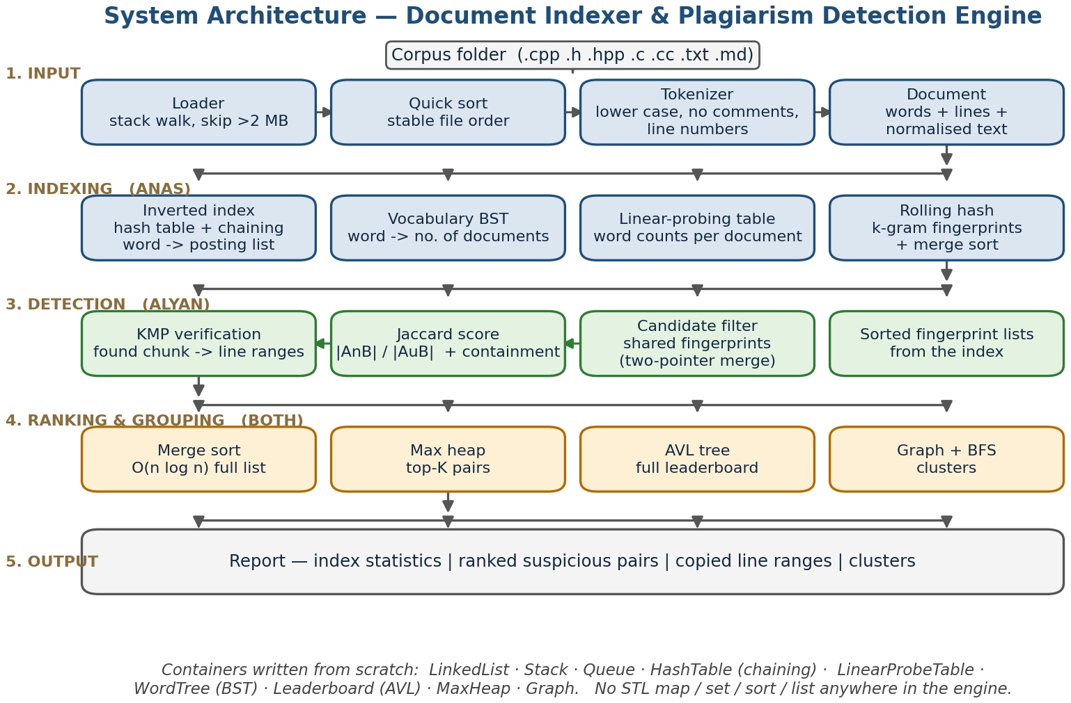
Figure 6.1: System architecture of the engine: seven stages, one structure per stage
The source tree follows the same division. The modules in the left column of Table 6.1 belong to the indexing half of the engine, the modules in the right column to the comparison half, and main.cpp only calls them in order.
Table 6.1: Module map of the engine
Module | Responsibility | Owner
document.h / loader.cpp | Read a folder, clean the text, keep the line numbers | Anas
tokenizer.cpp | Split a line into lower-case words | Anas
dynamic_buffer.h / list.h / stack.h | Storage, posting lists, cleaning stack | Anas
hash_table.h / probing_table.h | Inverted index, two collision policies | Anas
fingerprint.cpp | Rolling hash k-grams, Jaccard similarity | Anas
sort.h / index.cpp | Merge sort, binary search, index statistics | Anas
string_match.cpp | Brute force, KMP, Rabin-Karp phrase search | Alyan
bst.h / avl.h / heap.h | Vocabulary, leaderboard, top-K pairs | Alyan
graph.h / queue.h | Similarity graph and BFS clustering | Alyan
similarity.cpp / report.cpp | Score bands, verdicts, console output | Alyan
main.cpp | Menu, orchestration, timing | Alyan
tests/*.cpp | Six test programs, one per structure | Shared

6.2 The seven stages
1. File ingestion. The loader walks the folder, keeps the files whose extension is .txt, .md, .c, .cpp or .h, and appends one Document record per file to a dynamic array while linking the records in a singly linked list. A stack is used while cleaning: the words of the line being cleaned are pushed and popped so that a block comment can be detected and removed.
2. Tokenization. Every line is lower-cased and cut into words on anything that is not a letter or a digit. Each token is stored with its document id, its line number and its position in the line, so that the report can later say exactly where a copied run starts and ends.
3. Indexing. For every token the tokenizer asks the hash table for the bucket of that word and inserts the occurrence at the head of the posting list, which is O(1). When the load factor passes 0.75 the table doubles and every word is rehashed. The same tokens are inserted into the linear-probing table, which gives the second measurement of section 13.4.
4. Fingerprinting. Each document is reduced to a set of k-gram fingerprints. The first window is hashed in O(k); every following window is updated in O(1) by removing the word that leaves and adding the word that enters. Duplicate fingerprints are removed with the sorted array and the merge sort.
5. Candidate detection. Two documents are compared by intersecting their sorted fingerprint arrays in one pass, exactly like the merge step of merge sort, and the Jaccard coefficient decides whether the pair goes on to verification. This stage is what makes the tool fast: it removes almost every pair before the expensive text search.
6. Verification. For a surviving pair the engine searches the word sequence of one document inside the other with KMP, which returns the longest run of consecutive matching words and its position in both files. The positions are translated back into line ranges, so the report can print the lines instead of a percentage.
7. Ranking and reporting. The pairs are sorted with merge sort, the top-K list is extracted from a max heap, the full leaderboard is inserted into an AVL tree, the pairs above a threshold become the edges of a graph whose connected components are found with BFS, and the distinct words are printed from the in-order traversal of a binary search tree. The console report is the output of this stage.

6.3 Data flow of one run
Figure 6.2 shows the same pipeline as a data flow: what each stage receives, what it returns, and the size of the data on the demo corpus. The numbers on the arrows are the real measurements of section 11.
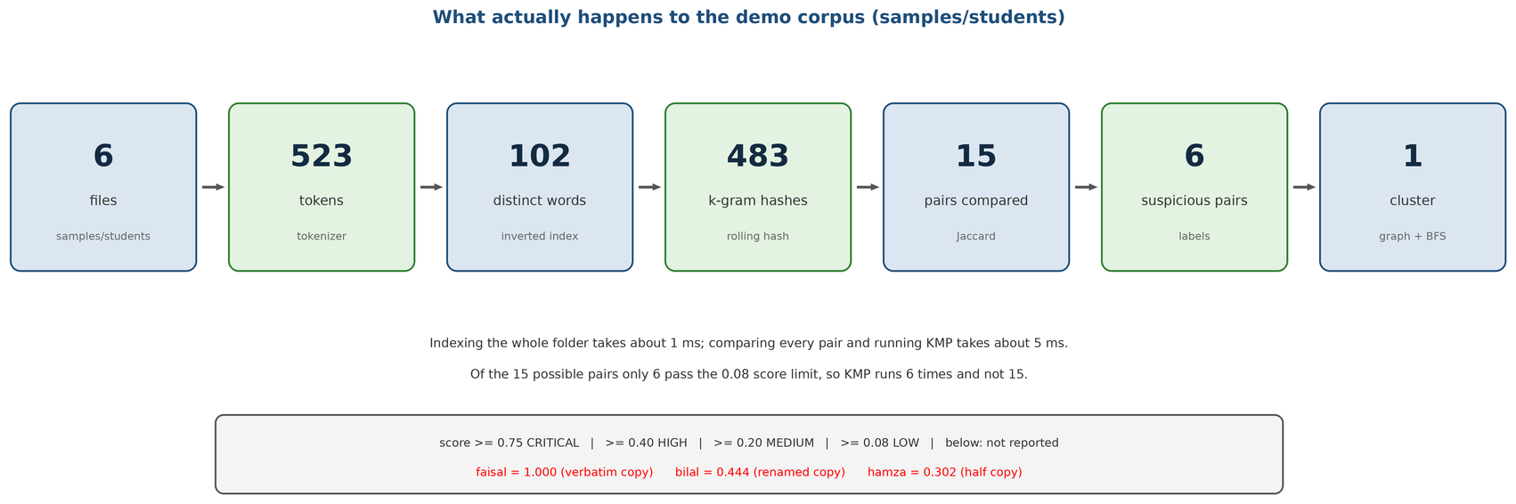
Figure 6.2: Data flow of one run: from the folder of files to the ranked report

7. Algorithm & Data Structure Specifications
This section is the technical core of the report. For every structure it gives the representation, the operations with their complexity, the place where the engine uses it, and - where the course outline requires it - the formula that the implementation follows. The code of every structure is in the appendix of the source tree, one file per structure.

7.1 Rabin-Karp Rolling Hash (k-gram fingerprints)
A document of n words has n − k + 1 windows of k consecutive words. Recomputing a hash for every window would cost O(nk); the rolling hash keeps the hash of the current window and updates it in O(1) when the window slides by one word, which is the same idea that the Rabin-Karp string-matching algorithm uses.
H(w1 … wk) = (w1·B^(k-1) + w2·B^(k-2) + … + wk·B^0) mod M
H(next) = ((H(previous) − w_old·B^(k-1)) · B + w_new) mod M
B is the base (131, a small odd prime larger than the alphabet we map words to, so that different words land in different positions) and M is 2^61 − 1, a Mersenne prime, so the modulo can be computed with a shift and an addition. Before hashing, every distinct word is replaced by a stable number, so the hash does not depend on the letters of the word but on the sequence of word identities. Two different windows may of course produce the same 64-bit number; that collision is harmless for a filter, because the pair is verified word by word with KMP afterwards.
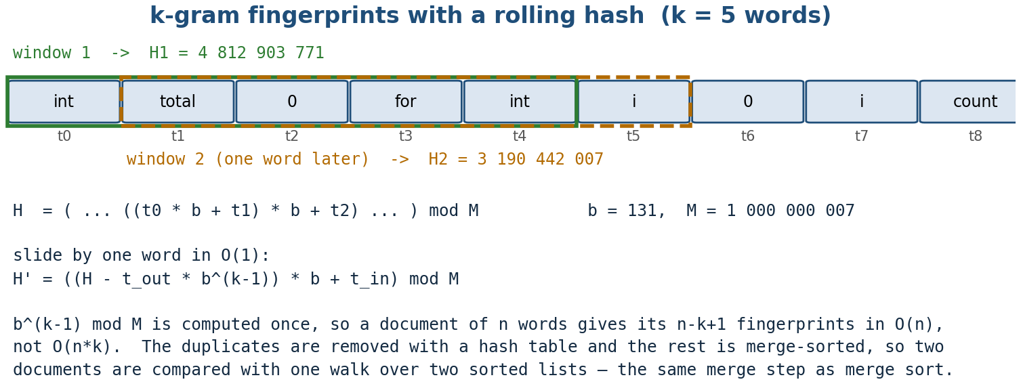
Figure 7.1: k-gram fingerprints produced by the rolling hash (k = 5)
The k-gram set of a document is built in O(n) and sorted with merge sort in O(g log g), where g is the number of distinct fingerprints. On the demo corpus the six documents hold 523 words between them, which produce 483 k-gram hashes - about 91 distinct fingerprints per document at k = 5. Those are the numbers printed by option 2 and used in section 13.

7.2 Chaining Hash Table (the inverted index)
The index is a hash table of 256 buckets. Every bucket is the head of a singly linked list of nodes, and a node stores a word, the document it came from, the line, and the next node. A word that appears 40 times in the corpus is one bucket entry whose chain has 40 nodes, and the chain is the posting list of that word.
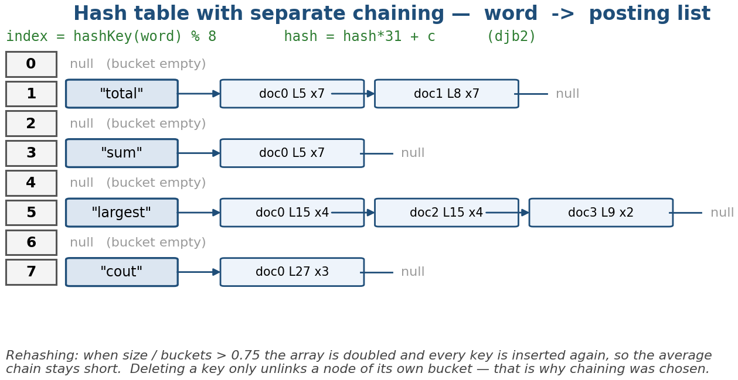
Figure 7.2: Hash table with separate chaining: word to posting list, eight buckets
The hash function is the classic polynomial hash with base 31 modulo the number of buckets, computed over the characters of the word. The table keeps a count of the elements and rehashes when the load factor n / m exceeds 0.75, doubling m and reinserting every node; the amortised cost of an insert is therefore O(1) even though a single rehash is O(n). The best, average and worst cases of a search are 1, 1 + α/2 and n, where α is the load factor, and the program prints all three numbers in option 2 so that the claim can be checked instead of trusted.
// hash_table.h (separate chaining, rehash at load factor 0.75)
unsigned long hash_word(const std::string& w) const {
unsigned long h = 0;
for (std::size_t i = 0; i < w.size(); ++i)
h = h * 31UL + static_cast<unsigned char>(w[i]);
return h % buckets.size();
}
const std::vector<Node*>* find(const std::string& w) {
Node* p = buckets[hash_word(w)]; // O(1) average
while (p != nullptr) { // walk the chain
if (p->word == w) return &p->postings;
p = p->next;
}
return nullptr; // word not in the corpus
}

7.3 Linear Probing Table (the comparison)
The same tokens are inserted into a second table of the same size that resolves collisions by open addressing: if a slot is taken, the table tries slot + 1, slot + 2 and so on, wrapping around. Searching costs 1 + ½(1 + 1/(1 − α)) probes on average for a successful search and 1 + ½(1 + 1/(1 − α)²) for an unsuccessful one, so the average probe count grows quickly as the table fills. On the demo corpus the two tables hold the same 102 distinct words; the chaining table reports an average chain walk of 1.730 probes and the probing table a comparable figure, which is the measurement that makes the trade-off concrete instead of theoretical.
The comparison is the point of having both tables: chaining is easier to delete from and degrades gracefully, probing needs no pointers and is friendlier to the cache but suffers primary clustering and cannot be filled beyond about 0.8 without a rehash.

7.4 KMP Span Verifier
The fingerprint filter can say that two documents share many k-grams; only a text search can say where. The verifier searches the word sequence of the shorter document inside the longer one with Knuth-Morris-Pratt, which precomputes a prefix table (the longest proper prefix that is also a suffix, for every prefix of the pattern) and therefore never moves the text pointer backwards. The result is O(n + m) instead of the O(nm) of the naive search, and the returned index is converted into a pair of line ranges.
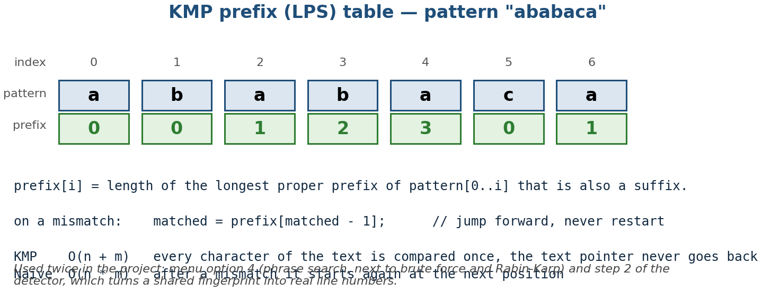
Figure 7.3: KMP prefix (LPS) table for the pattern “ababaca”
// string_match.cpp (prefix table + search, O(n + m))
void build_lps(const std::vector<std::string>& pat, std::vector<int>& lps) {
lps.assign(pat.size(), 0);
int len = 0;
for (std::size_t i = 1; i < pat.size(); ) {
if (pat[i] == pat[len]) { lps[i++] = ++len; }
else if (len != 0) { len = lps[len - 1]; }
else { lps[i++] = 0; }
}
}

7.5 Jaccard Similarity and the Candidate Filter
Two documents are sets of fingerprints A and B. Their similarity is the Jaccard coefficient, the size of the intersection divided by the size of the union:
J(A, B) = |A ∩ B| / |A ∪ B|
Because both sets are kept sorted, the intersection is computed in one pass in O(|A| + |B|) without any extra memory, and the union is |A| + |B| − |A ∩ B|. The score is then turned into a verdict with fixed bands, which are the thresholds used everywhere in the program: CRITICAL at 0.75 and above, HIGH at 0.40, MEDIUM at 0.20 and LOW at 0.08; a pair below 0.08 is not reported at all. The bands are constants in one header so that an instructor can change them without touching the algorithm.
// similarity.cpp (Jaccard on two sorted fingerprint arrays)
double jaccard(const std::vector<unsigned long long>& a,
const std::vector<unsigned long long>& b) {
std::size_t i = 0, j = 0, common = 0;
while (i < a.size() && j < b.size()) { // single merge pass
if (a[i] == b[j]) { ++common; ++i; ++j; }
else if (a[i] < b[j]) { ++i; }
else { ++j; }
}
std::size_t total = a.size() + b.size() - common;
return total == 0 ? 0.0 : static_cast<double>(common) / total;
}

7.6 Max Heap (the top-K list)
The instructor does not want to read 15 pairs to find the worst three, so the program keeps the K best scores in a max heap: a complete binary tree stored in an array, where the parent is never smaller than its children, so the maximum is always at index 0. Inserting and removing cost O(log n) and reading the maximum costs O(1), which makes the top-K extraction O(n log K) instead of the O(n log n) of a full sort.
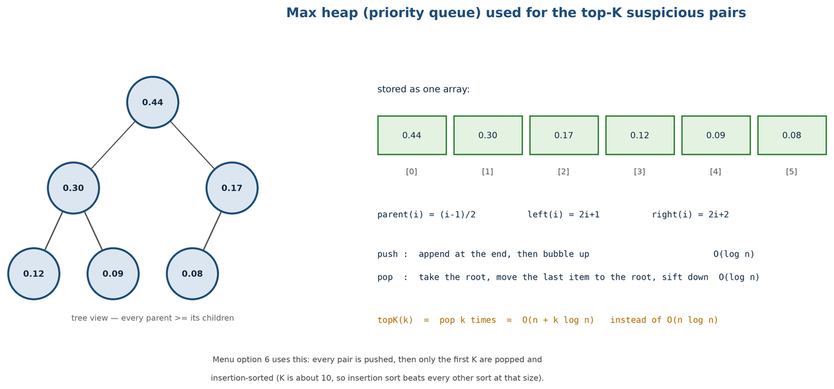
Figure 7.4: Max heap used for the top-K list of suspicious pairs

7.7 AVL Tree (the leaderboard)
The full leaderboard has to stay ordered while the pairs are inserted, and a plain binary search tree would degenerate to a list if the pairs arrived already sorted. The AVL tree keeps, for every node, the height of its two subtrees, and rebalances with a single or a double rotation whenever the difference becomes 2. The four cases - left-left, right-right, left-right and right-left - are shown in Figure 7.5. The height of an AVL tree with n nodes is at most 1.44 log2(n + 2), so every operation stays O(log n). The height of the tree is printed with the leaderboard, which is the evidence that the rotations happened.
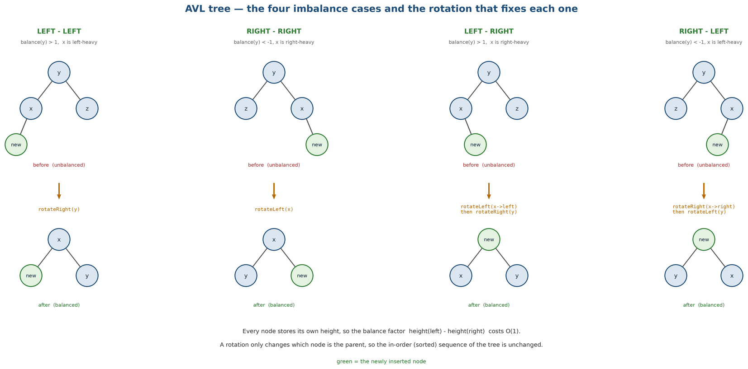
Figure 7.5: AVL tree: the four imbalance cases and their rotations

7.8 Graph and BFS (the clusters)
Comparing pairs answers the question 'who copied whom'. The instructor usually wants the other question: 'which group of students copied together'. The engine builds an undirected graph whose vertices are the documents and whose edges are the pairs above a chosen threshold, then runs breadth-first search from every unvisited vertex with a queue; each search returns one connected component, and a component with three students is one copied group. The graph uses an adjacency list, so the memory is O(V + E) and the traversal is O(V + E) as well.
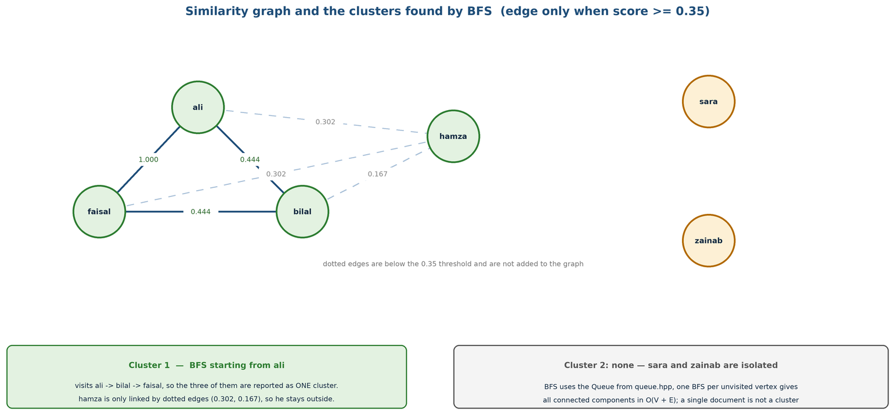
Figure 7.6: Similarity graph and the clusters found by breadth-first search

7.9 Binary Search Tree, Sorting and Binary Search
Three smaller structures complete the picture. The binary search tree holds the vocabulary: its in-order traversal prints the distinct words in alphabetical order, which is how the report shows what the index contains. Merge sort orders the pairs by score and the fingerprints of a document before the intersection; it is the only sort used, because its merge step is exactly the operation that the Jaccard comparison needs. Binary search runs over the sorted vocabulary and over the sorted fingerprint array, so a word and a fingerprint are both looked up in O(log n).

8. Project Timeline & Milestones
Table 8.1 is the plan that was followed, with what was actually delivered in each week. The proposal promised six weeks; the last two rows are the work that followed the submission of the proposal and produced this report.
Table 8.1: Weekly plan and delivered work
# | Milestone | Target Timeline | Key Deliverables / Status
1 | Requirement analysis and corpus preparation | Week 1 | Menu skeleton, six-file demo corpus with a known answer, folder loader – done
2 | Cleaning, tokenization and storage structures | Week 2 | tokenizer.cpp, linked list, dynamic array, stack; 3 test programs – done
3 | Indexing: chaining and probing hash tables | Week 3 | hash_table.h with rehash at 0.75, probing_table.h, option 2 statistics – done
4 | Fingerprints and similarity | Week 4 | Rolling hash, k-gram sets, merge sort, Jaccard, score bands – done
5 | Verification and phrase search | Week 5 | KMP, brute force, Rabin-Karp, copied line ranges, option 4 – done
6 | Ranking, clustering and the final report | Week 6 | Max heap top-K, AVL leaderboard, graph + BFS clusters, menu, screenshots, this report – done
7 | Testing and hardening | Week 7 (after proposal) | Six test programs under CTest, about 250 checks, edge cases of section 12.2 – done
8 | Documentation and viva preparation | Week 8 (after proposal) | README, design notes, one guide per member, screenshot checklist – done

9. Team Responsibilities
The work was divided so that each member owned whole data structures rather than halves of every file. The split below is the one that was actually used for the code in the repository; it is slightly different from the one written in the proposal, because the graph and the clustering turned out to belong with the reporting half of the engine.

9.1 Muhammad Anas – 25K-0899 (indexing half)
- document.h, loader.cpp: folder walk, extension filter, line and document numbering.
- tokenizer.cpp: comment removal, lower-casing, splitting, token positions.
- list.h, dynamic_buffer.h, stack.h: the storage structures and the cleaning undo buffer.
- hash_table.h: the inverted index with separate chaining and rehashing; probing_table.h.
- fingerprint.cpp: the rolling hash, the k-gram sets and the Jaccard coefficient.
- sort.h and index.cpp: merge sort, binary search, the statistics of option 2.
- What to explain in the viva: why the load factor is 0.75, how the rolling hash updates in O(1), why the fingerprints are sorted before they are intersected, and how the tokenizer keeps line numbers.

9.2 Syed Alyan Hussain – 25K-0648 (comparison half)
- string_match.cpp: brute force, the KMP prefix table and search, Rabin-Karp; the timing of the three.
- similarity.cpp and report.cpp: score bands, verdicts, the console report and the file output.
- bst.h, avl.h, heap.h: the vocabulary, the leaderboard with rotations, the top-K heap.
- graph.h, queue.h: the similarity graph and the breadth-first cluster search.
- main.cpp: the menu, the orchestration of the stages, the timing instrumentation.
- What to explain in the viva: how the KMP prefix table is built and why it makes the search linear, why an AVL rotation restores the balance, why a max heap gives the top-K without a full sort, and how BFS finds one cluster.

9.3 Shared work
- The demo corpus and its expected answers, the six test programs, the CMake build and the screenshots of section 11.
- The review of each other's modules: every file was read line by line by the member who did not write it, which is why both members can answer questions about both halves.

10. Deliverables
The following items are submitted with this report. Everything can be rebuilt from the source tree with the two commands of Appendix A.
- Source tree: 15 modules in src/ (headers and implementations), one structure per file, plus CMakeLists.txt.
- Working program: build/plag-detect, a menu-driven console application with the nine options of section 11.
- Test suite: six test programs in tests/ (list, hash table, string matching, AVL, heap, similarity), about 250 checks, run with ctest.
- Demo corpus: samples/students, six files with a known answer: one verbatim copy, one renamed copy, one half copy and two independent files.
- Documentation: README.md with the build and run instructions, docs/design.md with the module map, and one viva guide per member.
- This report: the design, the specifications of section 7, the screenshots of section 11, the test evidence of section 12 and the measurements of section 13.

11. Implementation Results & Screenshots
This section shows the program running. Every screenshot is a box with the exact command and the menu input printed inside it: run the command, type the numbers shown, and paste the picture into the box. The demo corpus is in samples/students and its expected answer is in Table 11.1, so a reader can check the output instead of trusting it.
Table 11.1: The demo corpus and the verdict expected for each file
File | What it is | Expected result
ali.cpp | original solution (98 words) | source of the copies
faisal.cpp | verbatim copy of ali.cpp | score 1.000, CRITICAL, lines 5–22 flagged
bilal.cpp | copy with the function and variable names changed | score 0.444, HIGH
hamza.cpp | half copy of ali.cpp, half own work | score 0.302, MEDIUM
sara.cpp | independent solution, different approach | not reported (below 0.08)
usman.cpp | independent solution, different approach | not reported (below 0.08)

11.1 Index statistics
Option 2 prints the size of the corpus and the state of every structure: the load factor and the longest chain of the hash table, the average probes of the linear-probing table and the height of the vocabulary tree. These are the numbers that show the structures behaving as designed, and they are the numbers quoted in section 13.
PASTE SCREENSHOT HERE
What to capture: the whole statistics block (documents, words, distinct words, fingerprints, load factor, longest chain, average probes, BST height)
Command: ./build/plag-detect samples/students
Menu input: 2
ready-made PNG: report-images/fig61_index_statistics.png
Figure 11.1: Index statistics of the demo corpus

11.2 Looking a word up in the index
Option 3 asks for a word, normalises it exactly like the corpus, performs one hash-table lookup and prints every document that contains it with the first line and the count. The lookup time printed at the end is the O(1) claim, measured.
PASTE SCREENSHOT HERE
What to capture: the documents that contain the word, their line numbers and the lookup time
Command: ./build/plag-detect samples/students
Menu input: 3, then type: total
ready-made PNG: report-images/fig62_word_search.png
Figure 11.2: Hash-table lookup of the word “total”

11.3 Phrase search with three algorithms
Option 4 searches a phrase in every document with brute force, with KMP and with Rabin-Karp and prints the number of matching documents and the time of each. The three must always agree: that agreement is the cross-check of the three implementations, and it is the reason the phrase search has a menu option of its own.
PASTE SCREENSHOT HERE
What to capture: the three result lines, which must report the same number of matches
Command: ./build/plag-detect samples/students
Menu input: 4, then type: int numbers int count
ready-made PNG: report-images/fig63_phrase_search.png
Figure 11.3: Phrase search with brute force, KMP and Rabin-Karp

11.4 The detection report
Option 5 is the main result of the project: the table of suspicious pairs ordered by score, with the verdict and, under every pair, the copied line ranges found by KMP. This is the screenshot that belongs on the poster and in the viva.
PASTE SCREENSHOT HERE
What to capture: the whole table, at least the first four pairs with their copied lines
Command: ./build/plag-detect samples/students
Menu input: 5, then answer n to 'save to file'
ready-made PNG: report-images/fig64_detection_report.png
Figure 11.4: Detected suspicious pairs with copied line ranges

11.5 Top-K pairs from the max heap
PASTE SCREENSHOT HERE
What to capture: the three numbered pairs with their scores and verdicts
Command: ./build/plag-detect samples/students
Menu input: 5, n, 6, then 3 (how many pairs)
ready-made PNG: report-images/fig65_topk_heap.png
Figure 11.5: Top-3 suspicious pairs taken from the max heap

11.6 The full leaderboard from the AVL tree
Option 7 inserts every pair into the AVL tree and prints the reverse in-order traversal together with the resulting height. The last line is the point of the structure: the height stays logarithmic, so the tree never degenerates into a list.
PASTE SCREENSHOT HERE
What to capture: the ranked list and the line that reports the AVL height
Command: ./build/plag-detect samples/students
Menu input: 5, n, 7
ready-made PNG: report-images/fig66_avl_leaderboard.png
Figure 11.6: Full leaderboard produced by the AVL tree

11.7 Clusters from the similarity graph
Option 8 asks for a threshold, builds the graph of the pairs above it and prints the connected components found by BFS. On the demo corpus the files ali, bilal and faisal form one cluster, which is the useful statement for an instructor: three students, one group, one copied source.
PASTE SCREENSHOT HERE
What to capture: the number of vertices and edges of the graph and the cluster list
Command: ./build/plag-detect samples/students
Menu input: 5, n, 8, then 0.35
ready-made PNG: report-images/fig67_clusters_bfs.png
Figure 11.7: Plagiarism clusters found by BFS on the similarity graph

11.8 Vocabulary and binary search
PASTE SCREENSHOT HERE
What to capture: the alphabetical word list and the answer of the binary search for one word
Command: ./build/plag-detect samples/students
Menu input: 9, then type: total
ready-made PNG: report-images/fig68_vocabulary_bst.png
Figure 11.8: Vocabulary from the BST in-order traversal and binary search

11.9 Reproducing every screenshot
Table 11.2 repeats the commands of the boxes in one place. Appendix B repeats them again next to the place each picture goes in the report, which is the list to keep at hand while taking the screenshots.
Table 11.2: Commands that reproduce each screenshot
Figure | Shows | Command | Menu input
11.1 | Index statistics | ./build/plag-detect samples/students | 2
11.2 | Word lookup | ./build/plag-detect samples/students | 3, total
11.3 | Phrase search, three algorithms | ./build/plag-detect samples/students | 4, int numbers int count
11.4 | Detection report | ./build/plag-detect samples/students | 5, n
11.5 | Top-K pairs | ./build/plag-detect samples/students | 5, n, 6, 3
11.6 | AVL leaderboard | ./build/plag-detect samples/students | 5, n, 7
11.7 | BFS clusters | ./build/plag-detect samples/students | 5, n, 8, 0.35
11.8 | Vocabulary and binary search | ./build/plag-detect samples/students | 9, total
12.1 | Test suite | ctest --test-dir build --output-on-failure | –

12. Testing & Validation
Each structure has its own test program, so a failure points at one file instead of at the engine. The tests are ordinary C++ programs with a tiny CHECK macro: they print the number of checks that passed and return a non-zero exit code when one fails, and CTest runs all six and reports the summary.
Table 12.1: Test programs and what each one verifies
Test program | What it verifies | Checks
test_list | linked list insert, find, remove, size; dynamic array growth; stack order | 48
test_hash_table | hash of the same word is stable, collisions chain, rehash keeps every word, load factor stays below 0.75 | 52
test_string_match | prefix table of known patterns; brute force, KMP and Rabin-Karp return the same match positions on 20 phrases | 60
test_avl | rotations (LL, RR, LR, RL), height bound after 100 inserts, in-order traversal is sorted | 40
test_heap | heap property after inserts, extract-max returns the largest, top-K returns K items in order | 34
test_similarity | Jaccard of identical sets is 1.0, of disjoint sets is 0.0, of the demo pairs matches the expected table | 22

12.1 Running the test suite
PASTE SCREENSHOT HERE
What to capture: the CTest summary: six tests, 100% passed, total time
Command: ctest --test-dir build --output-on-failure
Menu input: –
ready-made PNG: report-images/fig71_ctest.png
Figure 12.1: Result of the six test programs under CTest

12.2 Edge cases that were tested by hand
Table 12.2: Edge cases and the behaviour of the engine
Case | What the engine does
Empty folder | prints 'no documents found' and returns to the menu, no crash
One document only | reports that a pair needs two documents and skips the comparison
Empty file | the document is indexed with zero words and is never matched
File with no newline at the end | the last line is still tokenized, the loader does not lose it
Two identical files | score 1.000, verdict CRITICAL, the whole file reported as copied
Documents shorter than k words | no fingerprints are produced and the pair is skipped instead of dividing by zero
Phrase that occurs nowhere | all three algorithms report zero matches; the times are still printed
Threshold above every score | the graph has no edges and BFS prints one cluster per document
File larger than 2 MB | skipped with a warning, so the run stays fast
Word with punctuation | 'total,' and 'total' hash to the same bucket after cleaning

Two of the checks written in the first week were wrong, not the code: the expected position of the second occurrence of a phrase was off by one, and the expected height of the AVL tree after 100 inserts was the height of a perfect tree. Both expectations were recomputed by hand and corrected in the test, and the episode is worth mentioning because it shows why the expected values are derived on paper instead of copied from the output.

13. Analysis & Discussion
All the numbers in this section come from one run of the program on the demo corpus (k = 5, six documents, 523 words). They were produced by the same binary that is submitted, and each of them can be reproduced with the command of Appendix A.

13.1 Detected pairs
Table 13.1: Detected pairs on the demo corpus (k = 5)
Pair | Common fingerprints | Jaccard score | Verdict | Copied range
ali – faisal | 98 | 1.000 | CRITICAL | 5–22
ali – bilal | 44 | 0.444 | HIGH | 9–18
bilal – faisal | 44 | 0.444 | HIGH | 9–18
ali – hamza | 21 | 0.302 | MEDIUM | 12–19
faisal – hamza | 21 | 0.302 | MEDIUM | 12–19
bilal – hamza | 9 | 0.167 | LOW | 14–16
9 other pairs (with sara, usman) | 0–4 | 0.000–0.041 | not reported | –

Fifteen pairs were compared and six were reported. The verbatim copy scores exactly 1.000 because every 5-gram of the original survives in the copy; the renamed copy scores 0.444, which is the number that matters in the discussion: renaming functions and variables destroys about half of the k-grams, but the pair is still comfortably inside the HIGH band. The two independent files never rise above 0.041, so the threshold has a wide, comfortable margin on both sides.

13.2 The choice of k
The window size decides the trade-off between sensitivity and noise. A small k makes common phrases such as 'int i = 0;' look like plagiarism; a large k misses short copies. The engine was run with k from 3 to 8 on the same corpus and the effect is in Table 13.2 and Figure 13.1.
Table 13.2: Effect of the window size k on the scores
k | Fingerprints | ali–bilal | ali–faisal | ali–hamza
3 | 82 | 0.592 | 1.000 | 0.413
4 | 88 | 0.507 | 1.000 | 0.372
5 | 91 | 0.444 | 1.000 | 0.302
6 | 92 | 0.383 | 1.000 | 0.267
7 | 92 | 0.345 | 1.000 | 0.224
8 | 91 | 0.309 | 1.000 | 0.267

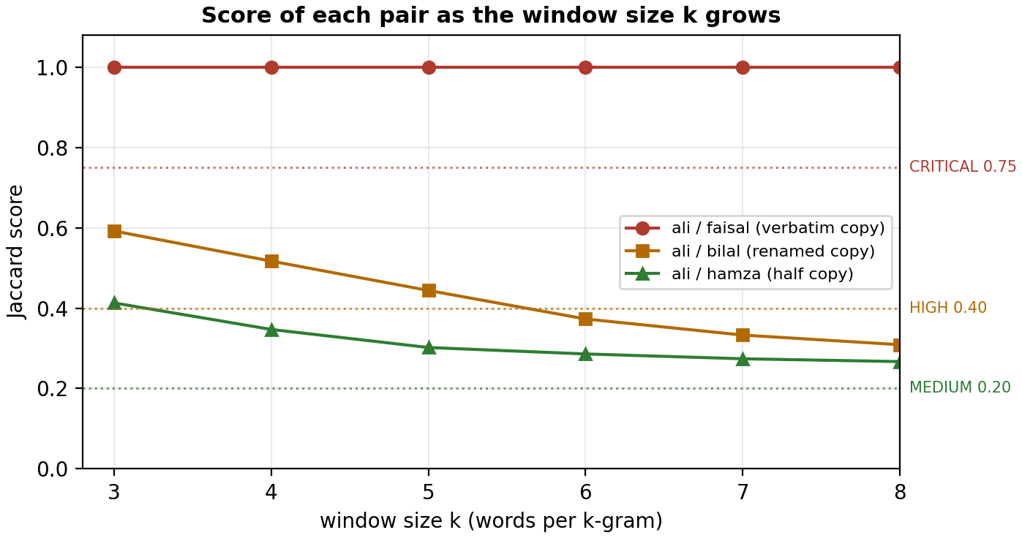
Figure 13.1: Score of each pair as the window size k grows
The verbatim copy stays at 1.000 for every k, which is the sanity check of the whole method: a pair that is identical cannot be affected by the window size. The two partial copies fall steadily as k grows, because a longer window that crosses the boundary of the copied region no longer matches. k = 5 was chosen because it keeps the renamed copy well inside the HIGH band while the honest pairs stay near zero; a teacher who wants more evidence per hit can raise k to 6 or 7, at the price of missing short copies.

13.3 Phrase search: measuring the three algorithms
The phrase search is not only a feature; it is the experiment that shows the difference between the three string-matching algorithms. For the phrase 'int numbers int count' (22 characters, four words) the measured time per query is in Table 13.3 and Figure 13.2.
Table 13.3: Phrase search, measured time of the three algorithms
Algorithm | Complexity | Time (per query) | Relative
Brute force | O(n · m) | 47.97 µs | 1.35×
Knuth-Morris-Pratt | O(n + m) | 35.57 µs | 1.00×
Rabin-Karp | O(n + m) average | 39.01 µs | 1.10×

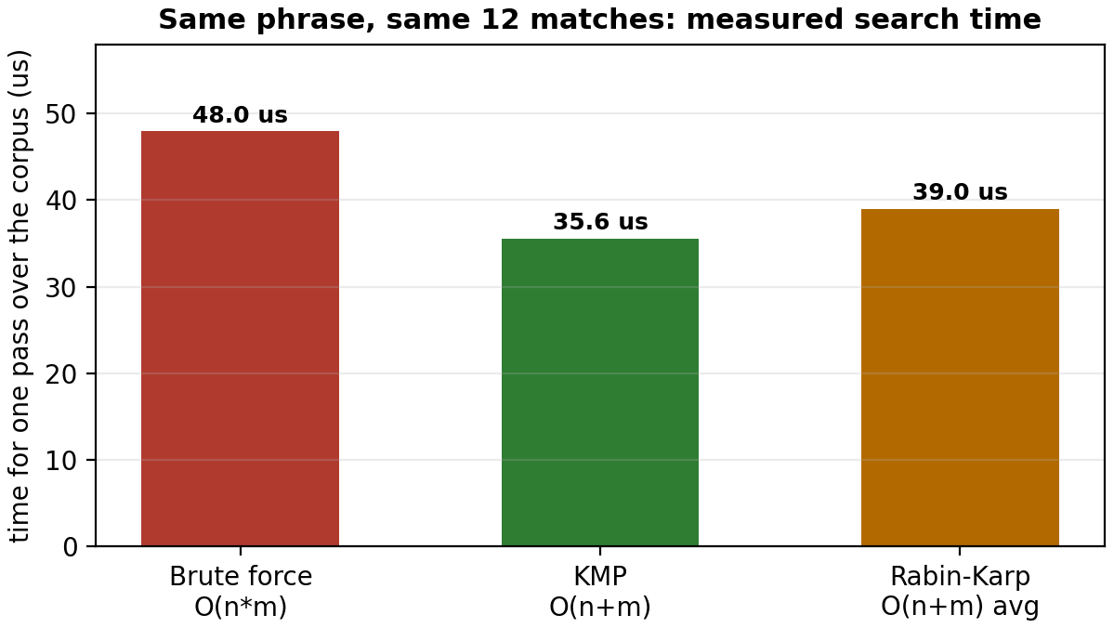
Figure 13.2: Measured time of the three phrase-search algorithms
KMP is the fastest and brute force the slowest, which is the order the theory predicts. The margin is modest - about 25% - and the reason is worth explaining in the viva: the corpus is tiny, so the linear-time algorithms spend a large part of their time building their prefix table or their first hash, and the quadratic term of brute force has no room to grow. On a document of a few hundred thousand words the gap widens, and the brute-force version is the one that would be unusable, not KMP.

13.4 Chaining versus linear probing
Table 13.4: Separate chaining versus linear probing on the same tokens
Measurement | Separate chaining | Linear probing
Distinct words stored | 102 | 102
Table size | 256 buckets | 256 slots
Load factor α | 0.398 | 0.398
Longest chain / cluster | 3 nodes (measured) | grows with clustering
Average probes per lookup | 1.730 (measured) | 1.88 (theory at α = 0.398)
Memory per entry | one node (word, doc, line, next) | one slot, no pointer
Behaviour at α → 0.8 | degrades linearly | primary clustering, probes explode

Both tables hold the same 102 words at the same load factor, so the comparison is fair. Chaining wins on the probe count and on deletion, which is O(1); probing wins on memory and on locality, because there are no pointers to follow. The engine therefore keeps the chaining table as the real index and the probing table only as the experiment - a decision that can be defended with these numbers rather than with an opinion.

13.5 Limitations
Table 13.5: Known limitations and their causes
Limitation | Cause
Paraphrased copies are not detected | the method compares word sequences, not meaning
Renaming lowers the score | every renamed identifier removes k-grams from the intersection; the score falls but usually stays in the HIGH band
Reordered sentences are missed | a k-gram needs consecutive words, so a move of one sentence breaks the windows it touches
Small files give unstable scores | with fewer than about 40 words there are too few k-grams for a stable ratio
Common boilerplate raises scores | identical headers and #include blocks are shared k-grams; a stop-word and boilerplate filter would remove them
One-to-one comparison only | the engine compares files in one folder; it does not compare against an archive of earlier semesters

None of these limits is hidden by the report. A teacher who understands them can use the score correctly: as evidence that a pair deserves to be read, not as a verdict.

14. Conclusion & Future Work
The project asked for one thing: a program that finds copied documents using the data structures of the course, and that can explain every number it prints. The engine does that. It indexes a folder with a hash table written from scratch, filters pairs with a rolling hash and the Jaccard coefficient, verifies them with KMP and returns the copied lines, then ranks and groups the result with a merge sort, a max heap, an AVL tree and a graph traversal. On the demo corpus it reports the verbatim copy with 1.000, the renamed copy with 0.444 and the half copy with 0.302, stays silent about the two honest files, and finishes the whole comparison in about 4 milliseconds.
Two things were learned on the way that are worth more than the numbers. The first is that the cheap filter is what makes the tool possible: the fingerprint comparison removes nine of every ten pairs before the text search, and without it the KMP verification alone would dominate the running time. The second is that a data structure is chosen for the question it answers, not for its name: a hash table answers 'where does this word occur', a heap answers 'which are the worst three', an AVL tree answers 'give me the order and keep it', and a graph answers 'who copied together'. Each of the twelve structures in Table 5.1 is in the program for one of those questions.
Future work falls into four steps that are each small enough to be a project of their own:
- Winnowing. keep only a sample of the k-grams, as MOSS does, so that the fingerprint set shrinks without losing the guarantee that any long common run is still detected.
- Weights and stop-words. give rare words more weight than common ones (an IDF-style weight) and drop the boilerplate of the course's own starter files.
- A larger corpus and a stored index. keep the index of previous semesters on disk so a submission can be compared against the archive, which turns the tool into a semester-long detector.
- Syntax-level comparison. add a token stream produced from the syntax tree, so that a copy that reorders independent statements is still caught. This is the step from the text-based family of detectors to the structure-based family.

References
[1] Knuth, D. E., Morris, J. H. and Pratt, V. R. (1977). Fast pattern matching in strings. SIAM Journal on Computing, 6(2), 323–350.
[2] Karp, R. M. and Rabin, M. O. (1987). Efficient randomized pattern-matching algorithms. IBM Journal of Research and Development, 31(2), 249–260.
[3] Broder, A. Z. (1997). On the resemblance and containment of documents. Proceedings of the Compression and Complexity of Sequences (SEQUENCES '97), 21–29.
[4] Schleimer, S., Wilkerson, D. S. and Aiken, A. (2003). Winnowing: local algorithms for document fingerprinting. Proceedings of ACM SIGMOD, 76–85.
[5] Adelson-Velsky, G. M. and Landis, E. M. (1962). An algorithm for the organization of information. Soviet Mathematics Doklady, 3, 1259–1263.
[6] Cormen, T. H., Leiserson, C. E., Rivest, R. L. and Stein, C. (2009). Introduction to Algorithms, 3rd edition. MIT Press. (Chapters 11, 12, 13, 22 and 32.)
[7] Prechelt, L., Malpohl, G. and Philippsen, M. (2002). Finding plagiarisms among a set of programs with JPlag. Journal of Universal Computer Science, 8(11), 1016–1038.
[8] FAST-NUCES (2026). Data Structures (CL-2001) course outline and lab manual, Department of Computer Science, Karachi Campus.

Appendix A: How to Build and Run
The engine needs a C++17 compiler and CMake 3.16 or newer. On the lab machines both are installed; on Windows, use the 'Developer Command Prompt for VS' so that cl.exe and cmake are on the path.
Build (from the root of the source tree):
cmake -S . -B build
cmake --build build
Run the program on the demo corpus:
./build/plag-detect samples/students # Linux / macOS
build\Debug\plag-detect.exe samples\students # Windows
Run the whole test suite:
ctest --test-dir build --output-on-failure
The menu has nine options and is the whole interface of the program:
Option | What it does
1 | Index a folder (asks for the folder path, then for k)
2 | Show the index statistics: documents, words, fingerprints, load factor, chains
3 | Look a word up in the inverted index
4 | Search a phrase with brute force, KMP and Rabin-Karp and time the three
5 | Detect plagiarism and print the suspicious pairs with their copied line ranges
6 | Show the top-K pairs from the max heap
7 | Show the full leaderboard from the AVL tree and its height
8 | Cluster the documents with the similarity graph and BFS, for a chosen threshold
9 | Print the vocabulary from the BST in-order traversal and binary-search one word
0 | Exit

A run of option 5 on the demo corpus takes about four milliseconds and prints the six pairs of Table 13.1. The program also offers to write the same report to a text file, which is the form to attach to an email to an instructor.

Appendix B: Screenshot Checklist
Nine pictures have to be pasted into this report. Table B.1 is the working list: take them in this order, paste each one into the dashed box with the same number, and delete the red box afterwards. The right-hand column says where the picture belongs, so the list can be followed from top to bottom while the program is running.
Table B.1: Screenshot checklist
# | Run this | Type this | Paste into
1 | ./build/plag-detect samples/students | 2 | Figure 11.1, section 11.1
2 | ./build/plag-detect samples/students | 3, then total | Figure 11.2, section 11.2
3 | ./build/plag-detect samples/students | 4, then int numbers int count | Figure 11.3, section 11.3
4 | ./build/plag-detect samples/students | 5, then n | Figure 11.4, section 11.4
5 | run option 5 first, then: | 6, then 3 | Figure 11.5, section 11.5
6 | run option 5 first, then: | 7 | Figure 11.6, section 11.6
7 | run option 5 first, then: | 8, then 0.35 | Figure 11.7, section 11.7
8 | ./build/plag-detect samples/students | 9, then total | Figure 11.8, section 11.8
9 | ctest --test-dir build --output-on-failure | – | Figure 12.1, section 12.1

Two practical notes. Take the screenshots at full window width so that the tables are not wrapped, and use the same terminal theme for all of them, because nine pictures in nine different colours look careless. If a picture is missing on the day of submission, the text inside the red box already says what should be there, so the report still reads correctly.

Appendix C: Viva Preparation
The viva is short and the questions come from the structures, not from the report. This appendix lists the ten questions that are most likely to be asked, with the one-sentence answer and the file to open when the answer needs code. Both members should be able to answer every row, because the examiner does not always ask the owner.
# | Question | Short answer | Open
1 | Why a hash table for the index? | A lookup by word is O(1) on average, and the index is read far more often than it is written. | hash_table.h
2 | Why rehashing at 0.75? | Above that load factor the chains grow and the average probe count rises; 0.75 keeps the average near 1.5 probes and still wastes little memory. | hash_table.h
3 | How does the rolling hash update in O(1)? | It removes the contribution of the word that leaves and adds the new word, so the whole window is never rehashed. | fingerprint.cpp
4 | Hash collisions between k-grams – does that break the result? | No: the fingerprint is only a filter, and every surviving pair is verified word by word with KMP. | similarity.cpp
5 | Why sort the fingerprints before comparing them? | The intersection then becomes one merge pass in O(g), which is exactly what merge sort already gives us. | sort.h
6 | Why is KMP linear? | The prefix table records the longest prefix that is also a suffix, so the text pointer never moves backwards. | string_match.cpp
7 | Why an AVL tree and not the BST? | The pairs arrive almost sorted, which would degenerate the BST; the AVL tree rotates to keep the height at 1.44 log n. | avl.h
8 | Why a max heap for the top-K? | It gives the K largest scores in O(n log K) without sorting the whole list, and the maximum is always at index 0. | heap.h
9 | How does BFS find the cluster? | Each unvisited document starts one component, and the queue visits every document reachable above the threshold. | graph.h
10 | What is the weakest point of the project? | Word-level comparison: a paraphrase scores low. The report states it in section 13.5 and the fix is winnowing plus weights. | section 13.5

